

**Bishop Milner Catholic College**

Relationship & Sex Education (RSE) Policy

‘Be who you are meant to be, and you will set the world on fire.’ St Catherine of Sienna

**Review date: September 2025**

# Aims

The aims of relationships and sex education (RSE) at Bishop Milner Catholic College are to:

* to enable our students to better understand the nature of relationships
* to help students develop feelings of self-respect, confidence and empathy
* to create a positive culture around issues of sexuality and relationships
* to enable students to understand the importance of stable loving relationships, including marriage, for the bringing up of children
* to prepare students for the changes that occur to their bodies, minds and emotions as a consequence of growth from childhood to adulthood
* to know about the risks of being online and how to stay safe from exploitation
* to support all young people for life in modern Britain.

# Objectives

## To develop the following attitudes and virtues:

* reverence for the gift of human sexuality and fertility
* respect for the dignity of every human being – in their own person and in the person of others
* joy in the goodness of the created world and their own bodily natures
* responsibility for their own actions and a recognition of the impact of these on others
* recognising and valuing their own sexual identity and that of others
* celebrating the gift of life-long, self-giving love
* recognising the importance of marriage and family life
* fidelity in relationships.

## To develop the following personal and social skills:

* making sound judgements and good choices which have integrity, and which are respectful of the individual’s commitments
* loving and being loved, and the ability to form friendships and loving, stable relationships free from exploitation, abuse and bullying
* managing emotions within relationships, and when relationships break down, with confidence, sensitivity and dignity
* managing conflict positively, recognising the value of difference
* cultivating humility, mercy and compassion, learning to forgive and be forgiven
* developing self-esteem and confidence, demonstrating self-respect and empathy for others
* building resilience and the ability to resist unwanted pressures, recognising the influence and impact of the media, internet and peer groups and so developing the ability to assess pressures and respond appropriately
* being patient, delaying gratification and learning to recognise the appropriate stages in the development of relationships, and how to love chastely
* assessing risks and managing behaviours in order to minimise the risk to health and personal integrity.

## To know and understand:

* the Church’s teaching on relationships and the nature and meaning of sexual love
* the Church’s teaching on marriage and the importance of marriage and family life
* the centrality and importance of virtue in guiding human living and loving
* the physical and psychological changes that accompany puberty
* the facts about human reproduction, how love is expressed sexually and how sexual love plays an essential and sacred role in procreation
* how to manage fertility in a way which is compatible with their stage of life, their own values and commitments, including an understanding of the difference between natural family planning and artificial contraception
* how to keep themselves safe from sexually transmitted infections and how to avoid unintended pregnancy, including where to go for advice.

# Statutory requirements

As a secondary academy school, we must provide RSE to all pupils as per section 34 of the [Children and Social work act 2017.](http://www.legislation.gov.uk/ukpga/2017/16/section/34/enacted)

In teaching RSE, we are required by our funding agreements to have regard to [guidance](https://www.gov.uk/government/consultations/relationships-and-sex-education-and-health-education) issued by the secretary of state as outlined in section 403 of the [Education Act 1996.](http://www.legislation.gov.uk/ukpga/1996/56/contents)

At Bishop Milner Catholic College, we teach RSE as set out in this policy.

# Policy Development

This policy has been developed in consultation with staff, pupils and parents. The consultation and policy development process involved the following steps:

1. Review – a working group pulled together all relevant information including relevant national and local guidance.
2. Senior Leader consultation – all Senior Leaders were given the opportunity to look at the policy and make recommendations.
3. Parent/stakeholder consultation – parents and any interested parties were invited to read about the policy and make recommendations.
4. Pupil consultation – we investigated what exactly pupils want from their RSE.
5. Ratification – once amendments were made, the policy was shared with governors and ratified.

# What is effective Relationship & Sex Education

It is lifelong learning about physical, moral and emotional development. It is about the understanding of the importance of a stable and loving relationship. It is also about the teaching of sex, sexuality, and sexual health as well as preparing students at school for opportunities, responsibilities and experiences of later life. It is not about the promotion of sexual orientation or sexual activity. Our curriculum is also designed to support children growing up in an increasingly complex and digital world. Whilst the internet is an overwhelmingly positive development in our lives, it does present significant challenges, particularly for young people. The dominance of social media, the prevalence of cyberbullying and the risk that children learn about relationships from untrustworthy sources – we aim to support children to make the right decisions and keep themselves safe and happy. The content and delivery of RSE at College will be conducted in an age appropriate way.

## Values

Each pupil is entitled to social and moral education that includes issues relating to personal relationship, sex sexuality and procreation. Consistent with Catholic teaching that sex and sexuality is a gift from God and should be valued and as with all relationships based on mutual respect and love which wills the others good in all things: ‘To love is to will the good of the other’ (St Thomas Aquinas)

As a faith school we endeavor to explore appropriate and safe connections with others, including friendships, relationships, and sex education. Not only this; we think that it is vital that students across all Key Stages can have the opportunity to evaluate the models of friendship and family in the modern world, as well as the integral principles of tolerance and diversity reflected in our multi-cultural community. *We acknowledge that “there will be a range of opinions regarding RSE. The starting principle when teaching each of these must be that the applicable law should be taught in a factual way so that pupils are clear on their rights and responsibilities as citizens*.’ (Department for Education Statutory Guidance RSE and Health Education page 1)

As a Catholic school our teaching is also reflective of the moral teachings of the Church and the gospels. We will make it clear what is the moral teaching of our specific religious tradition and what is legal under British law. Pupils will be given opportunity to explore and express different perspectives on moral issues relating to sex and relationships.

## Personal and Social Skills

RSE encourages students to manage emotions and relationships confidently and sensitively whilst developing self-respect and empathy for others. Students are taught to make choices based on an understanding of difference, with an absence of prejudice and learning how to recognise and avoid exploitation and abuse. It also provides opportunities to develop communication skills and assertiveness within a range of different situations.

## Knowledge and Understanding

RSE focuses on understanding physical development at appropriate stages. The students will explore; human sexuality, reproduction, sexual health, emotions and relationships. Students will also be provided with information on contraception and the range of local and national sexual health advice support services. Students will look at the reasons for delaying sexual

activity, the benefits to be gained from such delay and the avoidance of unplanned pregnancy. This will provide an objective and balanced view of sexual matters, correcting any misconceptions and misinformation students may have gained.

# Delivery of RSE at Bishop Milner Catholic College

## Balanced and Integrated

We will ensure that RSE is sensitive to the different needs of individual pupils and is taught in a way that allows access to those pupils at different stages of cognitive and emotional development. Since a Catholic school is committed to the education of the whole person, teaching on relationships and sexuality needs to be reflected in each relevant part of the curriculum. Whilst, for example, some aspects of RSE will be more appropriately explored in science lessons and some more appropriately explored in RE lessons, each should be informed by the other.

Each discipline should speak with consistency about the meaning of human love and the virtues that are enshrined in the Church’s teaching on human love. The teachings of the Catholic Church will be made explicit but whilst also respecting that in a diverse society other views are espoused by different sections of society and our own pupils. This foundation is echoed in the government documentation. “*Effective RSE does not encourage early sexual experimentation. It should teach young people to understand human sexuality and to respect themselves and others. It enables young people to mature, build their confidence and self- esteem and understand the reasons for delaying sexual activity.”* (Department for Education Statutory Guidance RSE and Health Education page 1)

## How is relationship and sex education taught

The government requirements in terms of curriculum will be met across subject areas but primarily in RE, Science and PSHE lessons. Since a Catholic school is committed to the education of the whole person, teaching on relationships and sexuality needs to be reflected in each relevant part of the curriculum.

The RE department will deliver those elements of the curriculum that are best taught and explored in RE lessons, the teaching of the Catholic Church will be explained, other views will be examined and discussed. The RE Department and PSHE curriculum will utilise the resources from the Ten-Ten programme that have been authorised by the Archdiocese of Birmingham (see **Appendix 2**).

In lessons pupils with explore how humans are:

**Created and loved by God (this explores the individual**) The Christian imperative to love self, made in the image and likeness of God, shows an understanding of the importance of valuing and understanding oneself as the basis for personal relationships.

**Created to love others (this explores an individual’s relationships with others)** God is love. We are created out of love and for love. The command to love is the basis of all Christian morality.

**Created to live in community** – local, national & global (this explores the individual’s relationships with the wider world) Human beings are relational by nature and live in the wider community. Through our exchange with others, our mutual service and through dialogue, we attempt to proclaim and extend the Kingdom of God for the good of individuals and the good of society.

Whilst promoting Catholic virtues, schools should ensure that children and young people are offered a broad and balanced RSE programme which provides them with clear factual, scientific information when relevant and meets the statutory requirements placed on schools.

The leads in PSHE, RE, and Science, and where appropriate other subjects, will ensure that what is taught fulfils the government requirements for secondary schools. RSE focuses on giving young people the information they need to help them develop healthy, nurturing relationships of all kinds including:

* Families
* Respectful relationships, including friendships
* Online and media
* Being safe
* Sexual relationships and sexual health
* The Law

The College recognises the need to create a supportive and secure atmosphere where students can develop the confidence needed to talk, listen and think about relationships and sex education. In order to do this, teachers will:

* Establish ground rules with students
* Emphasise the importance of mutual respect
* Encourage reflection
* Make students aware of the relevant persons to approach in the College. For more information about our RSE curriculum, see ***Appendix 1***.

These areas of learning are taught within the context of family life taking care to ensure that there is no stigmatisation of children based on their home circumstances. Families can include single parent families, LGBT parents, families headed by grandparents, adoptive parents, foster parents/carers amongst other structures along with reflecting sensitively that some children may have a different structure of support around them, for example: they may be young carers.

We understand that teaching RSE in a secondary school should build on the learning at primary school. Through our network of feeder and Trust primary schools we work together to establish a benchmark for RSE provision to ensure that this learning will be built on developmentally.

Staff that deliver RSE at the College will be provided with CPD to ensure that they are skilled in their delivery.

## Specialist Support

The College also recognises that some aspects of RSE must be taught by specialists. From time to time the College will invite professional health experts in to deliver issues relating to RSE.

These will be asked to conform to the following:

* + - Visitors contributing to RSE will do so at the invitation of the College and will be qualified to make an appropriate contribution
    - Visitors must agree with the aims of the College in delivering its policy on RSE
    - When in class visitors will be supervised by a teacher who will be present at all times
    - Visitors will follow the College’s Safeguarding procedures if a disclosure occurs within

the classroom setting

* + - Visitors will know and understand where their contribution fits into the College’s

programme for RSE and Citizenship

## Dealing with sensitive issues

All teachers are given training on handling controversial topics, are made clear about confidentiality boundaries and know where/who to refer students to for confidential advice and support.

RSE is part of the College’s provision for Spiritual, Moral, Social and Cultural development. The following are protocols for discussion-based lessons with students:

* No one (teacher or student) will have to answer a personal question
* No one will be forced to take part in a discussion
* Meanings of words will be explained in a sensible and factual way
* Teachers may use their discretion in responding to questions and may say that the appropriate person to answer that question is the parent/carer
* It is expected that teachers’ personal beliefs and attitudes will not influence their teaching

of RSE

* If at any point a disclosure is made by a student it is the responsibility of the member of staff to follow the schools’ safeguarding policy and notify the College’s Designated Safeguarding Lead or Deputy DSL. Staff must also register any concerns for a student on CPOMs before notifying the Safeguarding Lead or Deputy DSL.

## For further information on how we keep our students safe consult our Safeguarding Policy

**via the College’s website.**

# Parental rights

We endeavour to work in partnership with parents, to provide children and young people with a relationship and sex education which is compatible with their physical, cognitive, psychological, and spiritual maturity, and rooted in a Catholic vision of education.

RSE is part of all students’ education and it is hoped that all will participate. Some parts of RSE are compulsory – these are part of the National Curriculum for Science. Parents have the right to withdraw their children from the [non-statutory/non-science] components of sex education within RSE up to and until 3 terms before the child turns 16. After this point, if the child wishes to receive sex education rather than being withdrawn, the school will arrange this.

Requests for withdrawal should be put in writing using the form found in ***Appendix 3*** of this policy and addressed to the Principal. A copy of withdrawal requests will be placed in the pupil’s educational record. The Principal will discuss the request with parents and take appropriate action. When the Principal receives such a letter he will invite the parents/carers to a meeting, at which the Principal will explain clearly what the College’s policy is and seek to accommodate the wishes and/or concerns of the parents/carers. If that is not possible the pupil will be withdrawn from RSE and placed in another class where suitable work and supervision will be provided.

# Roles and Responsibilities

## The Local Governing Body

The Local Governing Body will approve the RSE policy, and hold the Principal to account for its implementation.

## 7.2 The Principal

The Principal is responsible for ensuring that RSE is taught consistently across the school, and for managing requests to withdraw students from [non-statutory/non-science] components of RSE (see section 6).

## Staff

Staff are responsible for:

* + - Delivering RSE in a sensitive way
    - Modelling positive attitudes to RSE o Monitoring progress
    - Responding to the needs of individual students
    - Responding appropriately to students whose parents wish them to be withdrawn from the [non-statutory/non-science] components of RSE
    - Staff do not have the right to opt out of teaching RSE. Staff who have concerns about teaching RSE are encouraged to discuss this with the Principal

## 7.3 Students

Students are expected to engage fully in RSE and, when discussing issues related to RSE, treat others with respect and sensitivity. SENd students will be provided with support and differentiated resources as appropriate which will ensure RSE is accessible to them

# Procedure for Monitoring and Evaluating RSE

The policy and its implementation will be reviewed every 12 months. The College will appoint an RSE link governor. The policy will be monitored by the Assistant Principal, Stephen Lodge, whose responsibility it is to:

* Ensure that RSE is covered in the schemes of work for Personal, Social and Health Education
* Monitor the use of teaching and learning styles through learning walks
* Monitor the use of teaching materials through work scrutiny
* Evaluate the effectiveness of the schools programme
* Ensure the content is age appropriate.

## Useful links for Parents:

<http://www.brook.org.uk/> <http://www.sexeducationforum.org.uk/home.aspx>

<https://www.childline.org.uk/Explore/SexRelationships/Pages/SexRelationships.aspx> <http://www.legislation.gov.uk/ukpga/2017/16/section/34/enacted>

[https://www.gov.uk/government/publications/relationships-education-relationships-and-](https://www.gov.uk/government/publications/relationships-education-relationships-and-sex-education-rse-and-health-education) [sex-education-rse-and-health-education](https://www.gov.uk/government/publications/relationships-education-relationships-and-sex-education-rse-and-health-education)

**Appendix 1: RSE Curriculum**

**By the end of Secondary School Pupils should know:**

|  |  |
| --- | --- |
| TOPIC | PUPILS SHOULD KNOW |
| Families | * That there are different types of committed, stable relationships * How these relationships might contribute to human happiness and their importance for bringing up children * What marriage is, including their legal status e.g. that marriage carries legal rights and protections not available to couples who are cohabiting or who have married, for example, in an unregistered religious ceremony * Why marriage is an important relationship choice for many couples and why it must be freely entered into * The characteristics and legal status of other types of long-term relationships * The roles and responsibilities of parents with respect to raising of children, including the characteristics of successful parenting * How to: determine whether other children, adults or sources of information are trustworthy: judge when a family, friend, intimate or other relationship is unsafe (and to recognise this in others’ relationships); and, how to seek help or advice, including reporting concerns about others, if needed |
| Respectful relationships, including friendships | * The characteristics of positive and healthy friendships (in all contexts, including online) including: trust, respect, honesty, kindness, generosity, boundaries, privacy, consent and the management of conflict, reconciliation and ending relationships. This includes different (non-sexual) types of relationship * Practical steps they can take in a range of different contexts to improve or support respectful relationships * How stereotypes, in particular stereotypes based on sex, gender, race, religion, sexual orientation or disability, can cause damage (e.g. how they might normalise non-consensual behaviour or encourage prejudice) * That in school and in wider society they can expect to be treated with respect by others, and that in turn they should show due respect to others, including people in positions of authority and due tolerance of other people’s beliefs * About different types of bullying (including cyberbullying), the impact of bullying, responsibilities of bystanders to report bullying and how and where to get help * That some types of behaviour within relationships are criminal, including violent behaviour and coercive control * What constitutes sexual harassment and sexual violence and why these are always unacceptable * The legal rights and responsibilities regarding equality (particularly with reference to the protected characteristics as defined in the Equality Act 2010) and that everyone is unique and equal |

|  |  |
| --- | --- |
| TOPIC | PUPILS SHOULD KNOW |
| Online and media | * Their rights, responsibilities and opportunities online, including that the same expectations of behaviour apply in all contexts, including online * About online risks, including that any material someone provides to another has the potential to be shared online and the difficulty of removing potentially compromising material placed online * Not to provide material to others that they would not want shared further and not to share personal material which is sent to them * What to do and where to get support to report material or manage issues online * The impact of viewing harmful content * That specifically sexually explicit material e.g. pornography presents a distorted picture of sexual behaviours, can damage the way people see themselves in relation to others and negatively affect how they behave towards sexual partners * That sharing and viewing indecent images of children (including those created by children) is a criminal offence which carries severe penalties including jail * How information and data is generated, collected, shared and used online |
| Being safe | * The concepts of, and laws relating to, sexual consent, sexual exploitation, abuse, grooming, coercion, harassment, rape, domestic abuse, forced marriage, honour-based violence and FGM, and how these can affect current and future relationships * How people can actively communicate and recognise consent from others, including sexual consent, and how and when consent can be withdrawn (in all contexts, including online) |

|  |  |
| --- | --- |
| TOPIC | PUPILS SHOULD KNOW |
| Intimate and sexual relationships, including sexual health | * How to recognise the characteristics and positive aspects of healthy one-to-one intimate relationships, which include mutual respect, consent, loyalty, trust, shared interests and outlook, sex and friendship * That all aspects of health can be affected by choices they make in sex and relationships, positively or negatively, e.g. physical, emotional, mental, sexual and reproductive health and wellbeing * The facts about reproductive health, including fertility and the potential impact of lifestyle on fertility for men and women * That there are a range of strategies for identifying and managing sexual pressure, including understanding peer pressure, resisting pressure and not pressurising others * That they have a choice to delay sex or to enjoy intimacy without sex * The facts about the full range of contraceptive choices, efficacy and options available * The facts around pregnancy including miscarriage * That there are choices in relation to pregnancy (with medically and legally accurate, impartial information on all options, including keeping the baby, adoption, abortion and where to get further help) * How the different sexually transmitted infections (STIs), including HIV/AIDs, are transmitted, how risk can be reduced through safer sex (including through condom use) and the importance of and facts about testing * About the prevalence of some STIs, the impact they can have on those who contract them and key facts about treatment * How the use of alcohol and drugs can lead to risky sexual behaviour * How to get further advice, including how and where to access confidential sexual and reproductive health advice and treatment |

**Appendix 2: Ten-Ten curriculum overview**

* e sion 1



o.Ami I?

Se ion 3

Session .2 Session.

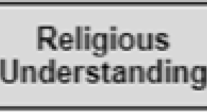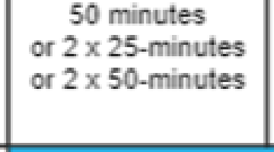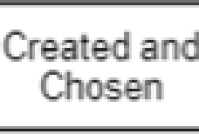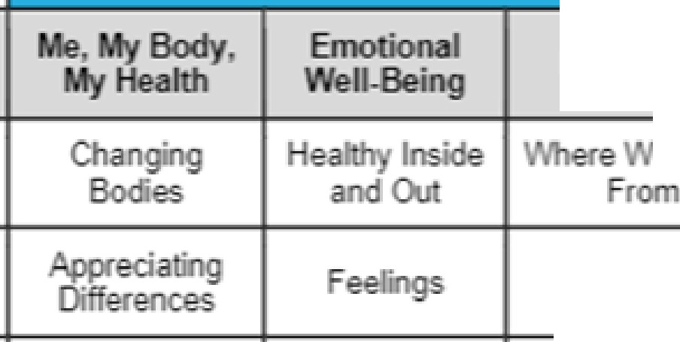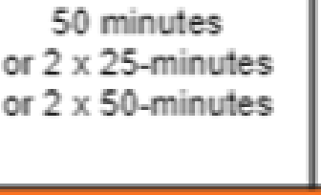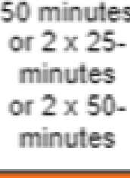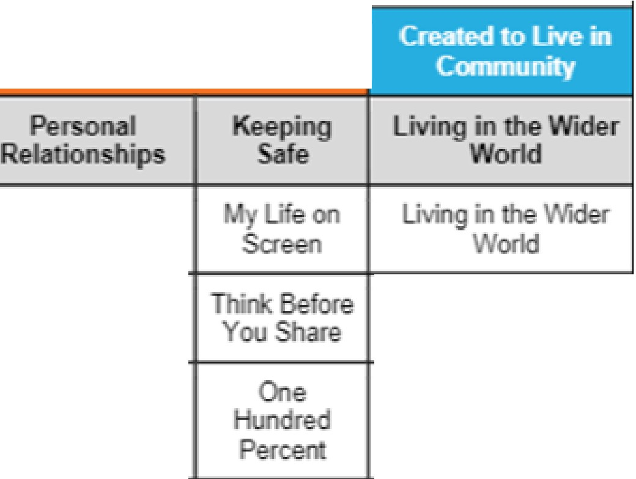

elf mage

**Year** 101& 11*

**Year9**

**Years**

**YNr7**

Sulb-'lihemes

Main Themes.

Sessions per progr mme

ar

(P nal

Reta· · • )

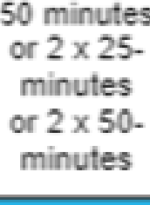

LifeC de

eCom

e ion 6

Sess on5

F . F ·e ds

ess,o:n 7



*The* Sea dh or

In Com o

Beorel

Born

T.ugh

Relationships

ania

Wi erWo.rld

Kn • Rights

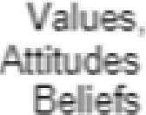lo *e*

Pfegn

Abortion

* Cyc:1€s)

Choices

and Responsib•i

ies

Abuse Sol"da•

**Appendix 3: Parent form: Withdrawal from sex education in RSE**

|  |  |  |  |
| --- | --- | --- | --- |
| TO BE COMPLETED BY PARENTS | | | |
| Name of child |  | Class |  |
| Name of parent |  | Date |  |
| Reason for withdrawing from sex education within relationships and sex education | | | |
|  | | | |
| Any other information you would like the school to consider | | | |
|  | | | |
| Parent signature |  | | |

|  |  |
| --- | --- |
| TO BE COMPLETED BY THE SCHOOL | |
| Agreed actions from discussion with parents |  |
|  |  |