Implementation at Bishop Milner Catholic College


To live out the St John Bosco Catholic Academy commitment to teaching and learning, with Christ at the centre of all we say and do, the following features are non-negotiables in Bishop Milner Classrooms.
- Catholic Social Teaching

All our subject curriculums provide rich and varied opportunities to explore the 7 key principles of CST. Teachers should support students in; making appropriate links, understanding what these teachings look like in practice and affirming the values of our faith (See Appendix 1).

- The Milner Way in Classrooms

Our behaviour curriculum makes it clear how staff and students must prioritise; Starting the lesson, Speaking and Listening, Presentation of work and Ending the Lesson (See Appendix 2).

Sixth Form students are not expected to stand behind chairs at the start and end of lessons but it must be made sure that outdoor clothing (including hats, coats and hoods) and headphones are removed and not worn in lessons. Expectations surrounding speaking and listening and presentation are in line with other Key Stages. Folders or books must be present every lesson with entries neatly organised and dated to reflect the learning journey over time.

- Teach Like a Champion

As a school that subscribes to Doud Lemov’s Methodology, teachers at Bishop Milner Catholic College must commit to the following 5 strategies in particular.
- Track the Speaker
- Stop and Jot
- Turn and Talk
- Build on Answers
- Actively Appreciate
(See Appendix 3)
Sixth Form expectations are in line with other Key Stages. Participation and engagement ratio should always be at 100% and with all students playing active leading roles in their own learning and the learning of others. In smaller groups, active appreciation of the contributions of others may be verbal (rather than non-verbal cues) but must be an explicit part of classroom culture.

- Adaptive Teaching

Teachers will plan and deliver lessons that ensure our fully inclusive curriculum is ambitious for all students, with books and folders showcasing how teaching and learning over time is adapted to offer ambition for all.
All adults are expected to use live marking codes that identify adaptions that are made in lessons to support, stretch and challenge students. (See Appendix 4)

In the sixth form expectations are in line for KS3 and KS4, however due to curriculum time and student numbers, individualised feedback to set tasks, or live marking that supports improvements should be seen at least weekly in all folders.
Marking codes might be useful for larger groups but in the majority of cases, smaller group sizes will allow for personalised close marking and in-depth individualised guidance.

- Assessment, Marking and Feedback

Teachers will
- Plan for regular and standardised opportunities to grade the work of students. Actual grades should be displayed/considered against target grades.
- Ensure routine use of ‘test conditions’ to assess unaided progress and to prepare students for formal examinations.
- In KS3, make explicit use of Progress Codes on assessment work to show how grades have been determined and to highlight targets for improvement.
- In KS4 and 5, make explicit use of mark scheme content on assessment work to show how grades have been determined and to highlight targets for improvement.
- Keep robust systems of the monitoring and tracking of graded work to help determine the necessary interventions.
- Provide students with feedback on paper in line with department policy. Personalised handwritten feedback will be shown in red pen (typing or use of stickers or stamps is acceptable) but all entries must adhere to policy and be dated. To reduce the workload of teachers, it is acceptable for feedback to take the form of our whole-college Teacher Feedback aid.
- Be it individually written feedback, or comments populated for a class, adhere to the ‘Here and Now’ principle of marking which is:
HERE: Positive acknowledgement and recognition of achievement/attainment.
NOW: An instructional command for progress to be made. These tasks should be differentiated to ensure that the feedback is appropriate for each student.
- Always provide students with the dedicated reflection time needed to follow these instructions and complete required improvements. No teacher feedback must be left without response. This progress is shown using purple pen.
- Champion high standards of SPAG, addressing issues with the college feedback codes.
- Dialogue on achievement and improvement should pervade your classroom. Live marking using the college adaption codes should be used and be visible in books and folders, and be more evident in books of disadvantaged students and students with SEN.

- Homework and Independent Learning

Teachers will set appropriate tasks for students to complete at home, that will complement their learning in the classroom. Staff should provide details of tasks to students and parents using the Arbor App.

There is no expectation for staff to give feedback on all pieces of homework or independent learning, however they may be used to form a judgement on students current levels of attainment.

Work set for Guided Learning sessions and tasks to be done at home mut be recorded on Arbor to support students in keeping on top of independent learning. For success at Post 16, research suggests that 5 additional hours of study, per subject, per week is necessary. While some of this should be self-directed, the volume and value of additional tasks set by teachers must always be carefully considered and well-resourced. The Sixth Form team are there to help actively support and monitor this.

Appendix 1
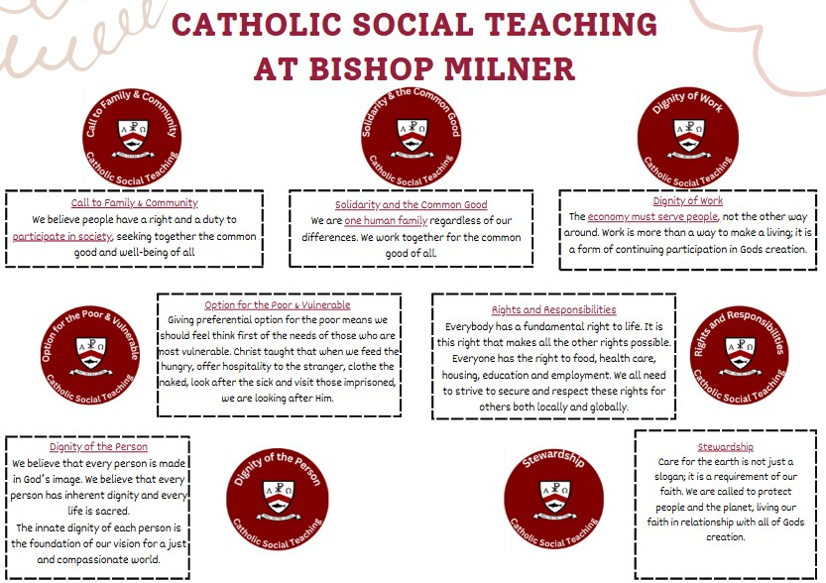
Appendix 2
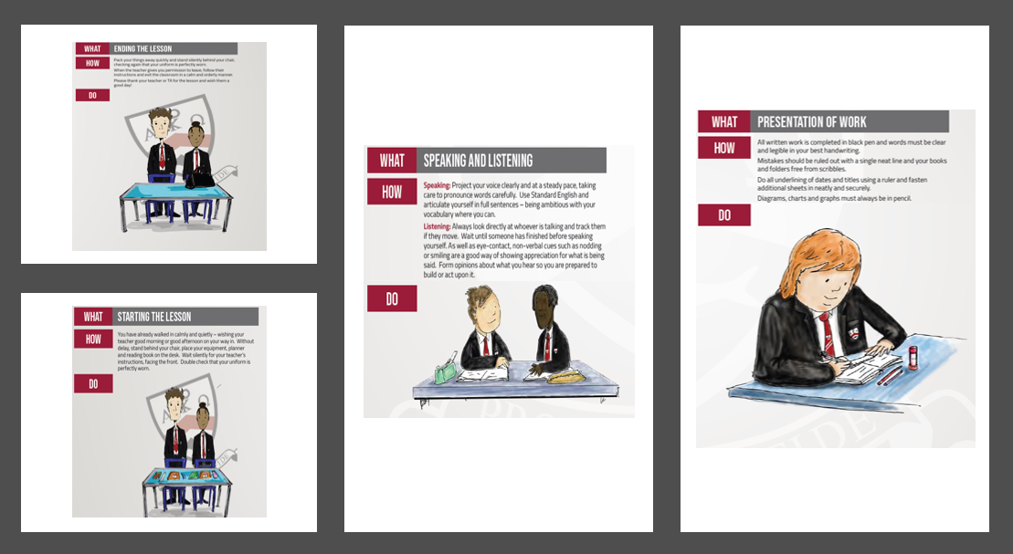

Appendix 3
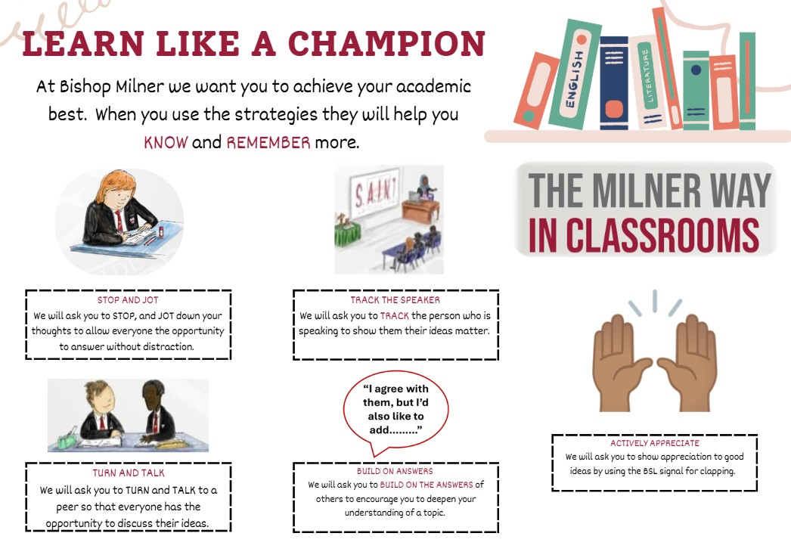
Appendix 4
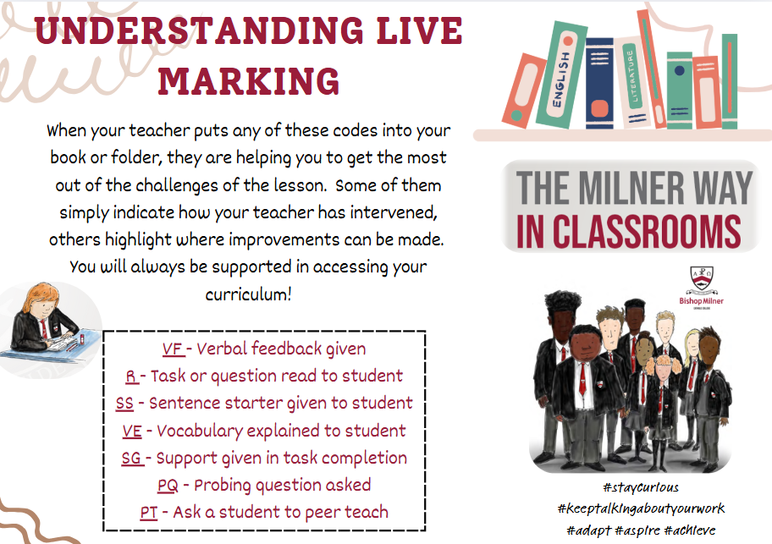

Let us Pray

As we work together to nurture the God-given Talents of each child in our care, may we always remember how special our calling:

